Jan Stephens, R.D., C.D.E., MSc.
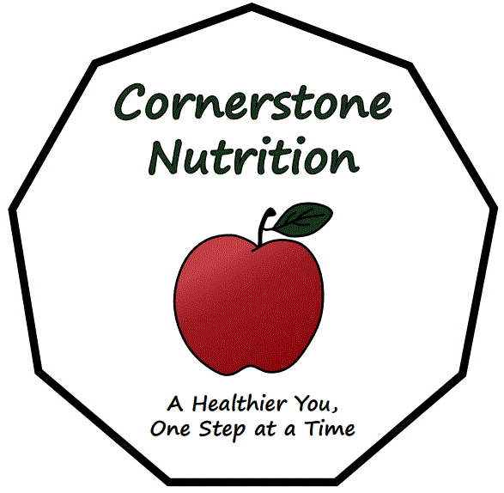
Cornerstone Nutrition,
3401 Beach Ave., Roberts Creek, BC, V0N 2W2
Phone: 604 741-7307 Fax: 604 885-3035

Nutrition Referral to Cornerstone Nutrition

Patient Name:
DOB:
PHN:
Address:
Phone #
E-Mail:

Relevant Family & Patient History:

Diet Requested or Reason for Referral:

Relevant Labs or Anthropometrics:

Signature of Physician

